Bates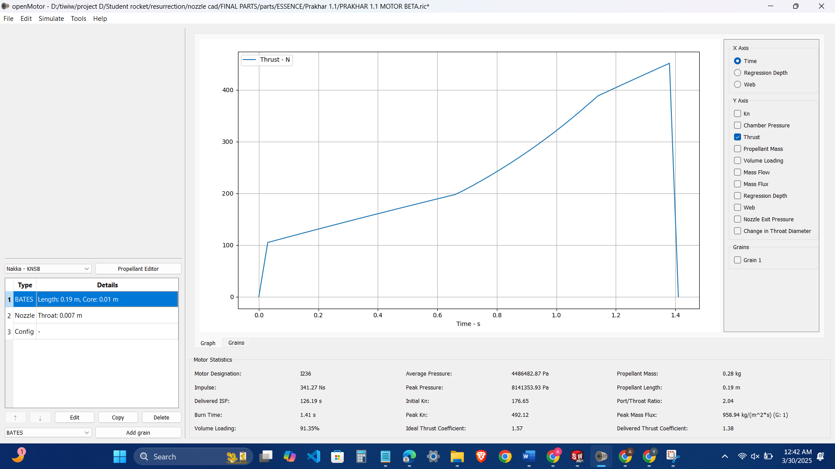

Conical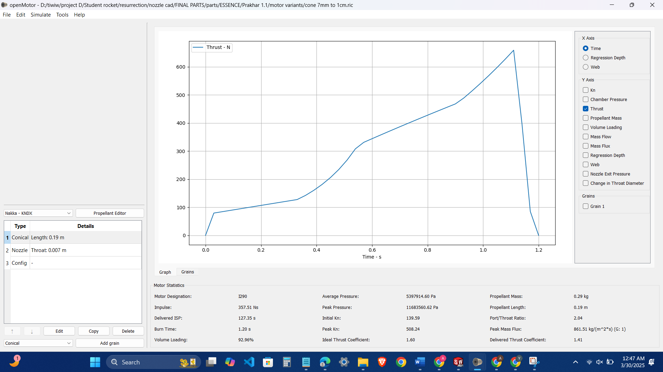

Rod and Tube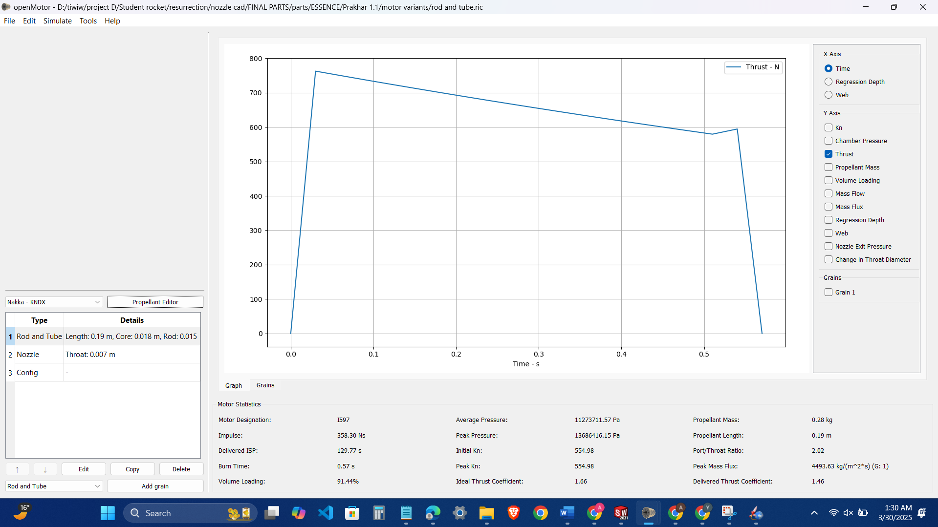

This one rod and tube has achieved 1300m at 136 atms and 0.57 s burn time

Finocyl

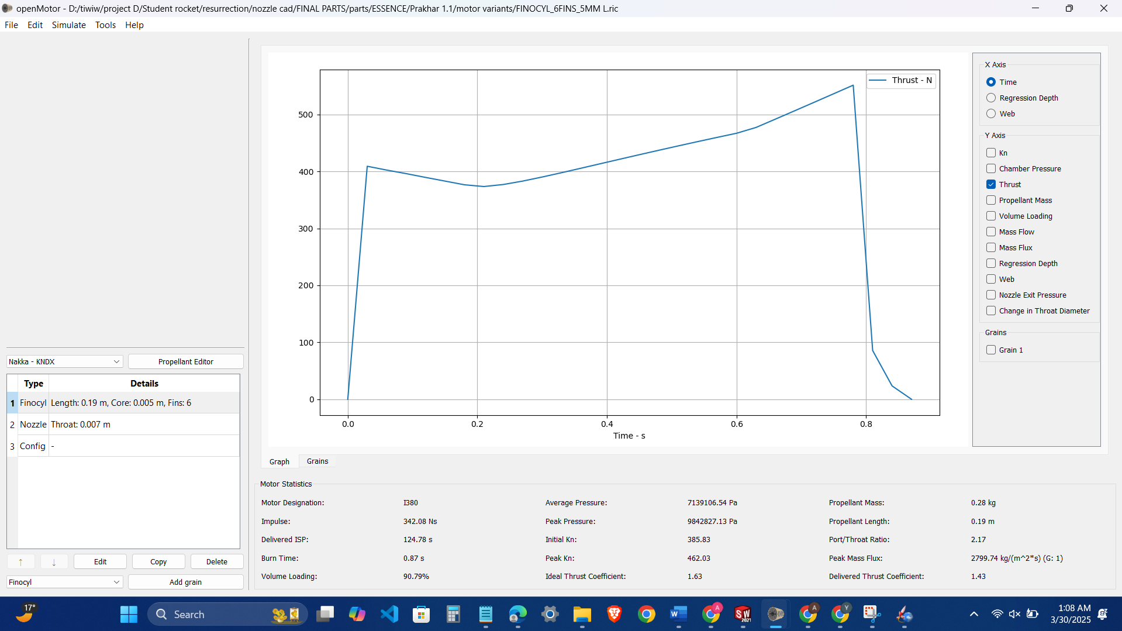

Moon Burner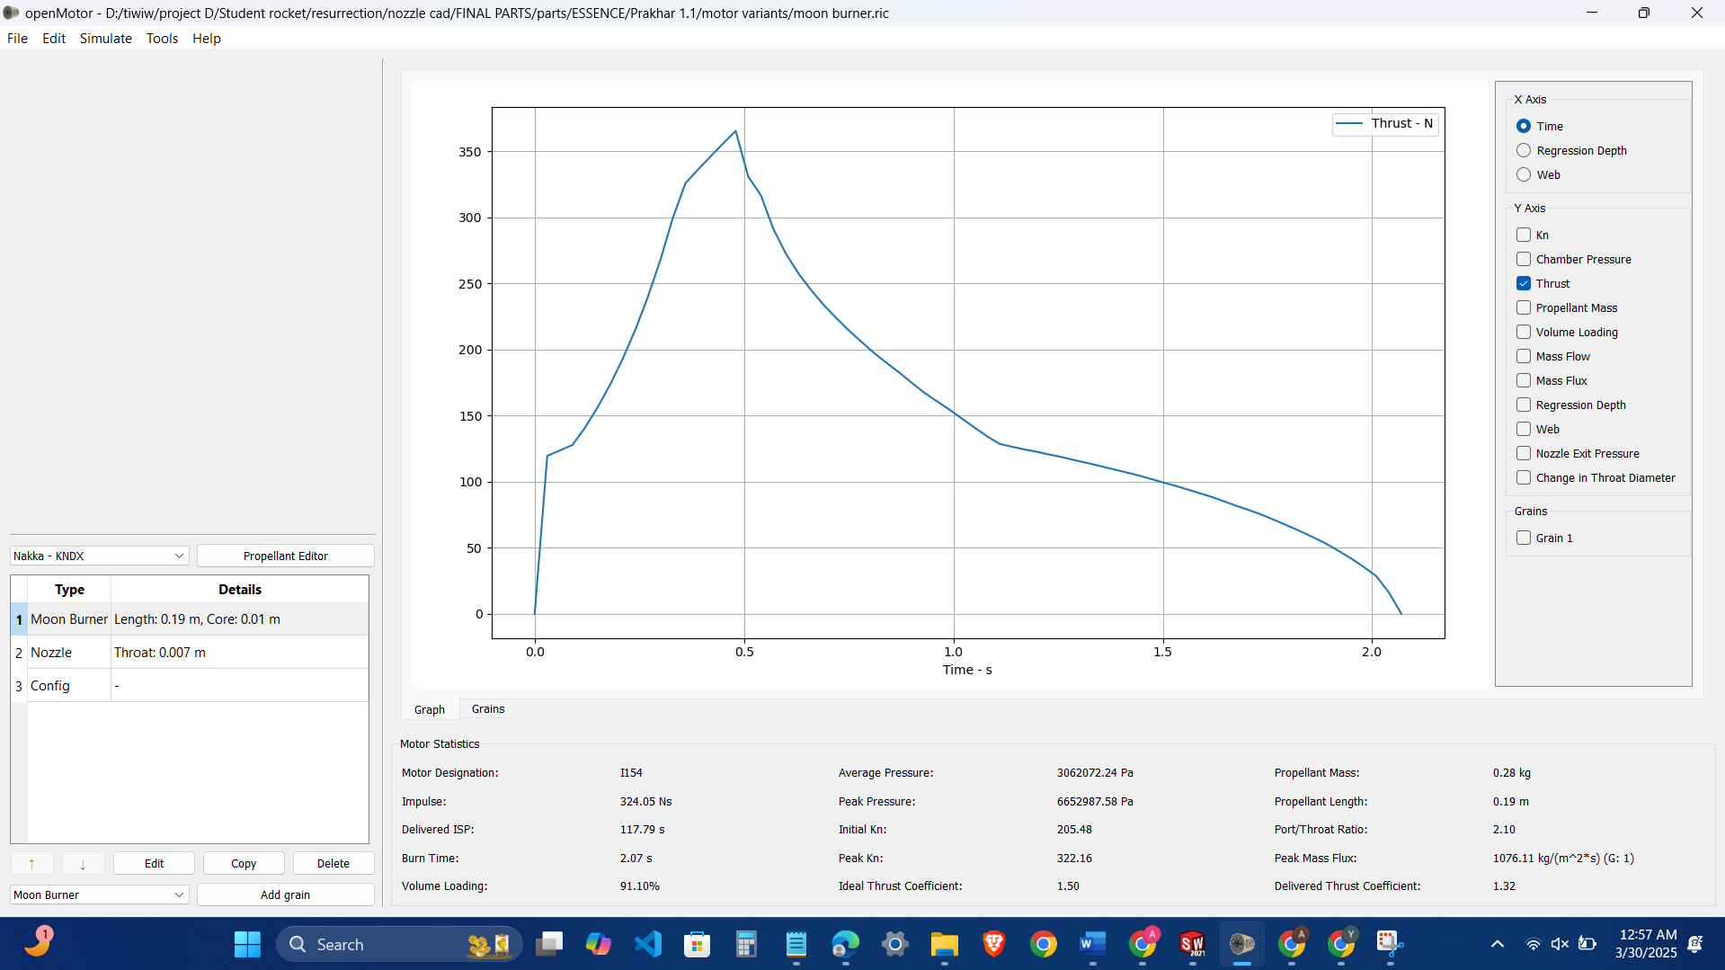

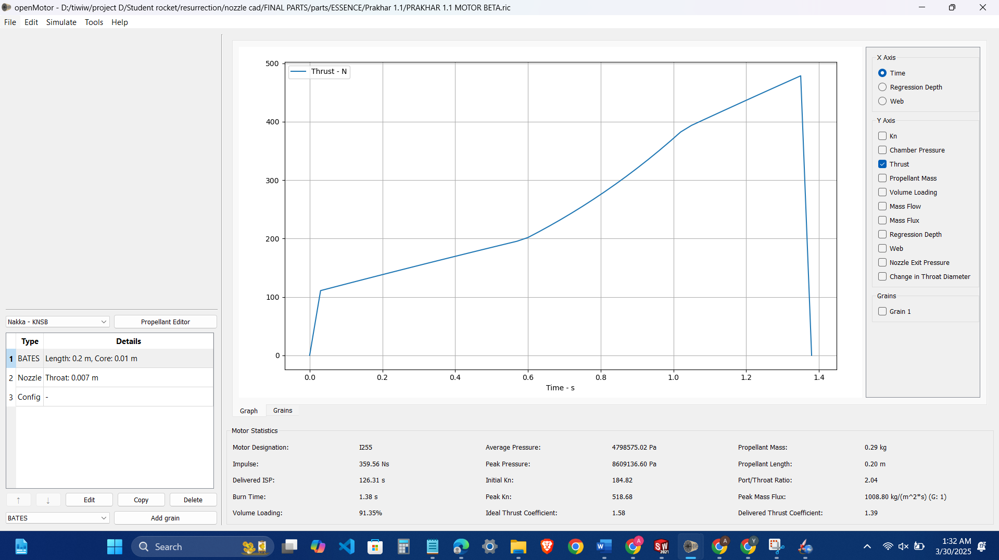

Bates has the best performance 1300 m for 86 bar of thrust and avg of 46 which is safe ….